./

Report – ONLINE MOVIE TICKETS BOOKING USIPROGRAMMIN

Course Code: <CODE>



Submitted By: Mounika CH

Candidate ID: 104361

Version Number:

Team Members :

Team No:

Module: Model Based System Engineering

|  |  |  |  |  |  |
| --- | --- | --- | --- | --- | --- |
| **Ver. Rel. No.** | **Release Date** | **Prepared. By** | **Reviewed By** | **Approved By** | **Remarks/Revision Details** |
| 0 | 21/09/2020 | Mounika CH |  |  |  |
| 1 | 23/09/2020 | Mounika CH |  |  |  |
| 2 | 25/09/2020 | Mounika CH |  |  |  |
|  |  |  |  |  |  |
|  |  |  |  |  |  |

**Document History**

**TABLE OF CONTENT**

|  |  |  |
| --- | --- | --- |
| Sl.No | Contents | Page No |
| 1 | Introduction | **2** |
| 2 | Problem Statement | **2** |
| 3 | Requirements | **3** |
| 4 | Procedure | **3** |
| 5 | Design | **3** |
| 6 | Test plan &Expected Results | **3-4** |

**21/09/2020**

**INTRODUCTION**

online Movie Ticket Booking System is based on the concept of booking movie tickets. There’s no login system available for this system, the user can freely use its feature.

Talking about the features of this Simple system, the user can book movie tickets. For this, the user has to select a movie name, enter customer details such as name and phone number.

The administrator will insert the movie data which includes movie name, movie code, release date, the price of the movie ticket. The user can easily view all movies data and find particular movie data and  can book movie tickets by filling details of  the user.

The system does not create an external file to store the user’s data permanently. This system is in C Programming Language and different variables, strings have been used for the development of it.

**How I choosed my project?**

I choose my project only based on C-Programming . It should consist of only software implementation (code) no hardware part should be involved. So I gone through so many projects in Google chrome  then I found the simple project that’s is online movie ticket booking. Since I am from electronics and communication background I am weak in the coding part. Hence I hope this project will make me understand more about application. In this project I have to code how to book movie tickets so I am here not using any android app development  just coding the how movie tickets are booked with some features.

**Version 1: 23/09/2020**

**PROBLEM STATEMENT**

The main purpose of this project is to provide a reliable, secure, efficient and user friendly environment to the customers and management authorities. Also benefit to the customer with efficient and faster service. The Project “Online Movie Ticket Booking System” as a wide scope as it is generalized software and can be easily used in any ticket booking process system with little or no change. The Changes in software can be easily accommodated. The addition and deletion of the modules in software can be easily adjusted. This project has a lot of scope for further enhancement too. This project can save money and efforts in managing the record, just a mouse click can make the task easy and faster.

**Requirements**

The hardware and software requirements of online movie ticket booking using c-programming is given below

**Hardware Requirement:**

1. Intel Pentium 3 processor or higher
2. RAM 256 MB
3. 40 GB HDD (Hard Disk)
4. CD Drive 16X or higher

**SOFTWARE REQUIREMENTS**

* 1. Web Browser :- Google Chrome
  2. Documentation :- MS Word 2007
  3. Project presentation :- MS PowerPoint 2007
  4. Coding Platform: github

**PROCEDURE**

1. The administrator will insert the movie data.
2. The user can view all the movie data and also can find particular movie information.
3. The user can book tickets for selected movie or multiple movies.
4. Provide a user details to book a tickets.

**Version 2:-25/09/2020**

**DESIGN  FLOW:-**

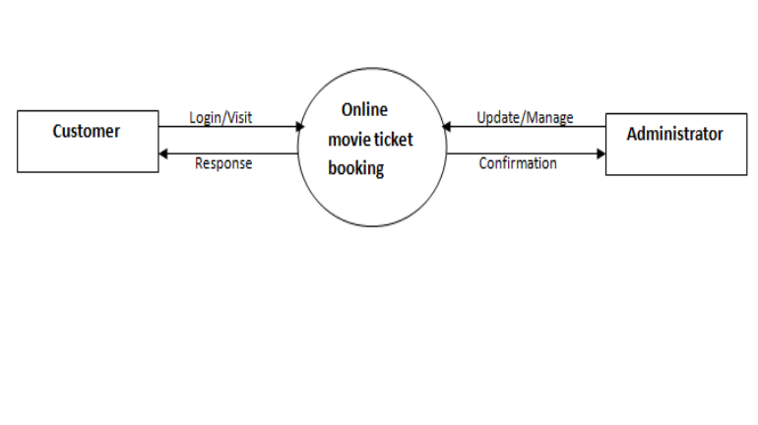

**Test plan and Expected output:-**

1. Insert movie
2. View all movie
3. Find movie
4. Book movie
5. Fill details
6. Exit

**Expected results table:-**

|  |  |  |
| --- | --- | --- |
| Enter your choice: 1 | Insert movie | Enter movie code :- 21  Enter  name :- fidda  Enter Release Date:25/09/2020  Enter Ticket Price:- 150  Record insert Successfull |
| Enter your choice:2 | View all movie | 21 fidda 25/09/2020  150 |
| Enter your choice:3 | Find Movie | Enter movie code :21  Record Found   Code :21   movie name :fidda   movie date :25/09/2020    price of ticket :150 |
| Enter your choice: 4 | Book Ticket | 21 fidda 25/10/2020 250  Enter movie code :21   Record Found    Code ::21    Movie name ::fidda    date name ::25/09/2020  Price of ticket::150 |
| Enter your choice:5 | Fill Details | your name :mounika   mobile number :8123568658   Total number of tickets :4   ***** ENJOY MOVIE ****   name : mounika    mobile Number : -8123568658     movie name : fidda     Total seats : 4     cost per ticket : 250    Total Amount : 1000 |